Cairo University Faculty of Computers and Information



**CS352 – Software Engineering II**

**Phase 2 Template**

**2017**

**Project Team**

|  |  |  |  |
| --- | --- | --- | --- |
| **ID** | **Name** | **Email** | **Mobile** |
|  | 1st name is team leader |  |  |
|  |  |  |  |
|  |  |  |  |
|  |  |  |  |
|  |  |  |  |
|  |  |  |  |

**[Write here your TA name only in your lab]**

Title page has no header or footer.

Docs must be supplied as pdf –files re-named as requested

Contents

Instructions [To be removed] 3

Your Restful API 3

Class diagram design 4

Daily scrum Meetings 5

Trello workspace screenshot 5

Github repository link 6

# Instructions[To be removed]

* **IMPORTANT. Rename this document to CS352-SE2016-LeaderID-TANAME-Phase2-a.docx**

**[Write TA name in your document name]**

**Examples:**

**CS352-20120001-MohamedSamir-Phase2.docx**

**CS352-20120001-OmarKhaled-Phase2-a.docx**

**CS352-20120001-RagiaMohamed-Phase2-a.docx**

* **Remove the following notes and any red notes**

# Your Restful API

* **Your restful API should provide read and write to your social network data**
* **In this section you should describe each service in your RESTful API**
* **For each service you list service Name input type (GET or POST), Service URL, parameters and description for each parameter, Example request, Example response**
* **For example: check description of one service from twitter Rest API here**

[**https://dev.twitter.com/rest/reference/get/statuses/mentions_timeline**](https://dev.twitter.com/rest/reference/get/statuses/mentions_timeline)

**ShowAllCourses**

|  |  |
| --- | --- |
| **Service name** | **showallcourses** |
| **Input type** | **Get** |
| **Service URL** | **http://localhost/showallcourses** |
| **Parameters** | |  |  | | --- | --- | | **NAME** | **Description** | | **request** | **To send ArrayList of all Course as parameter to jsp page** | |
| **Example request** | **Get**  **http://localhost/showallcourses** |
| **Example response** | **{"name":math,"age":"all ages","CourseID":"2","teacherid":"1","description":"all mathematic operation you can learn it in this course"}**  **{"name":DB,"age":"18 ,CourseID":"7","teacherid":"5","description":"learn how to deal with database"}** |

# 

# ShowMyCourse

|  |  |
| --- | --- |
| **Service name** | **showmycourses** |
| **Input type** | **Get** |
| **Service URL** | **http://localhost/showmycourses** |
| **Parameters** | |  |  | | --- | --- | | **NAME** | **Description** | | **request** | **To send ArrayList of teacher Courses as parameter to jsp page** | |
| **Example request** | **Get**  **http://localhost/showmycourses** |
| **Example response** | **{"name":math,"age":"all ages","CourseID":"1","teacherid":"1","description":"all mathematic operation you can learn it in this course"}**  **{"name":Graphics,"age":" 25","CourseID":"2","teacherid":"1","description":"learn algorithm to draw line,circle,etc"}** |

# ShowCourse

|  |  |
| --- | --- |
| **Service name** | **showcourses** |
| **Input type** | **Get** |
| **Service URL** | **http://localhost/showcourses** |
| **Parameters** | |  |  | | --- | --- | | **NAME** | **Description** | | **CourseID** | **Provide CourseID to be display** | |
| **Example request** | **Get**  **http://localhost/showcourses** |
| **Example response** | **{"name":math,"age":"all ages","CourseID":"2","teacherid":"1","description":"all mathematic operation you can learn it in this course"}** |

# Show course Form

|  |  |
| --- | --- |
| **Service name** | **addcourse** |
| **Input type** | **Get** |
| **Service URL** | **http://localhost/addcourse** |
| **Parameters** | |  |  | | --- | --- | | **NAME** | **Description** | | **Does not need parameters** |  | |
| **Example request** | **Get**  **http://localhost/addcourse** |
| **Example response** | **Form Contain**  **CourseName:**  **CourseAge:**  **CourseDescription:** |

# Add Course

|  |  |
| --- | --- |
| **Service name** | **addcourse** |
| **Input type** | **Post** |
| **Service URL** | **http://localhost/addcourse** |
| **Parameters** | |  |  | | --- | --- | | **NAME** | **Description** | | **Name**  **Age**  **description** | **Provide course information** | |
| **Example request** | **Post**  **http://localhost/addcourse** |
| **Example response** | **Redirect to page that contain all teacher courses how add the course** |

# Add Game

|  |  |
| --- | --- |
| **Service name** | **Add Game** |
| **Input type** | **Get** |
| **Service URL** | **http://localhost/ Add Game** |
| **Parameters** | |  |  | | --- | --- | | **NAME** | **Description** | | **request** | **Send Game information name, description ,Number of Question parameter to jsp page** | |
| **Example request** | <http://localhost/AddGame> |
| **Example response** | **Add Game Successfully** |

**Login**

|  |  |
| --- | --- |
| **Service name** | **Add Game** |
| **Input type** | **Get** |
| **Service URL** | **http://localhost/ login** |
| **Parameters** | |  |  | | --- | --- | | **NAME** | **Description** | | **password** | **Provide user password** | | **Email** | **Provide user email** | |
| **Example request** | http://localhost/login |
| **Example response** | **Login Form** |

**SignUp**

|  |  |
| --- | --- |
| **Service name** | **SignUP** |
| **Input type** | **Get** |
| **Service URL** | **http://localhost/ signup** |
| **Parameters** | |  |  | | --- | --- | | **NAME** | **Description** | | **password** | **Provide user password** | | **Email** | **Provide user email** | |
| **Example request** | http://localhost/signup |
| **Example response** | **SignUP Form** |

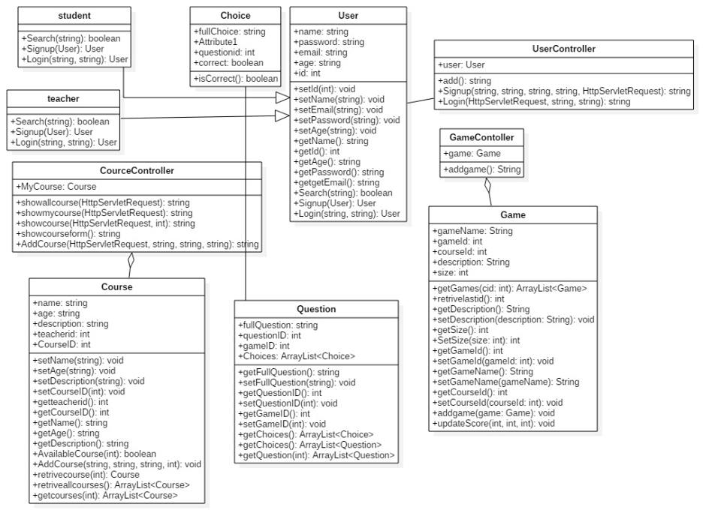

# 

# Sequence diagram

login

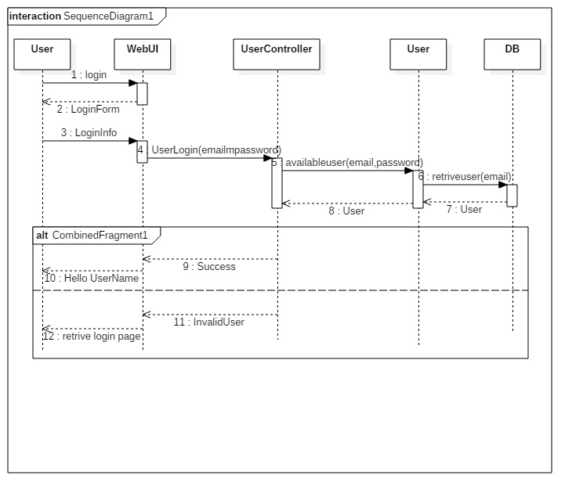

# signup

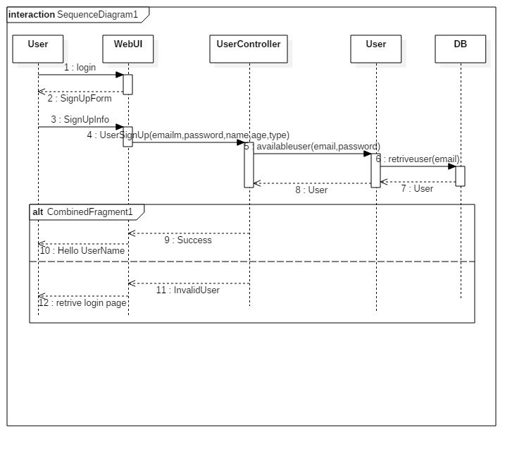

# Add Course

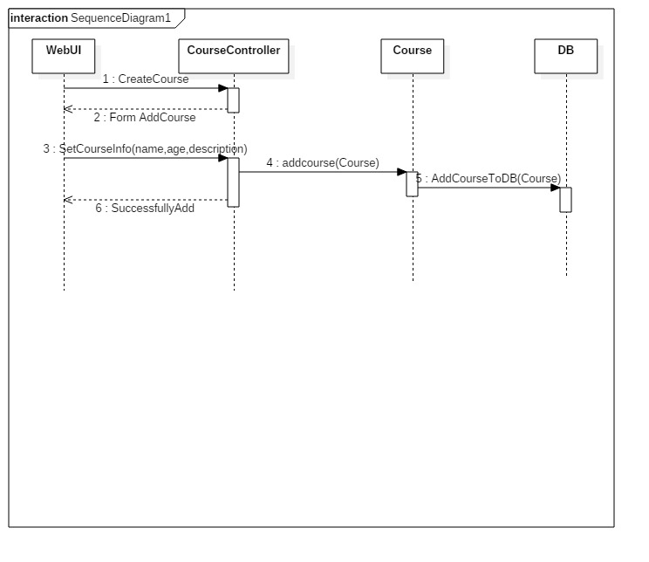

# Add Game

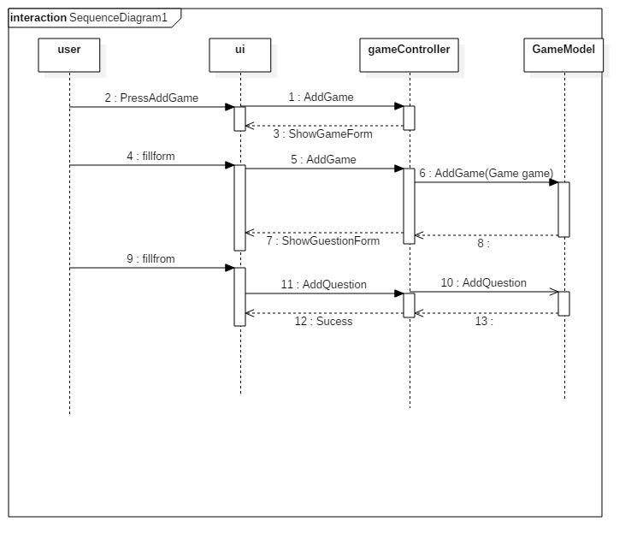

# 1-Spring boot Services

# 2-View (JSP)

# 3-Database (JDBC)

# 4-Connecting and Configuring the View,DB,Services (MVC)

# 5-Frontend (Bootstrap) Automation Testing (Selenium)

# Trello workspace screenshot

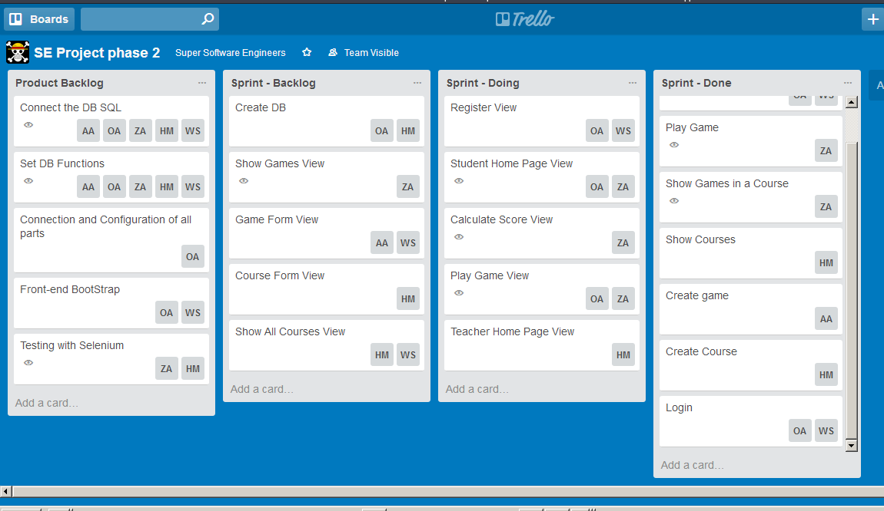

# Github repository link